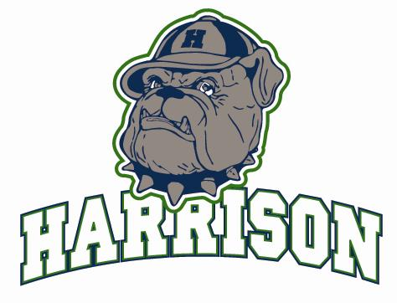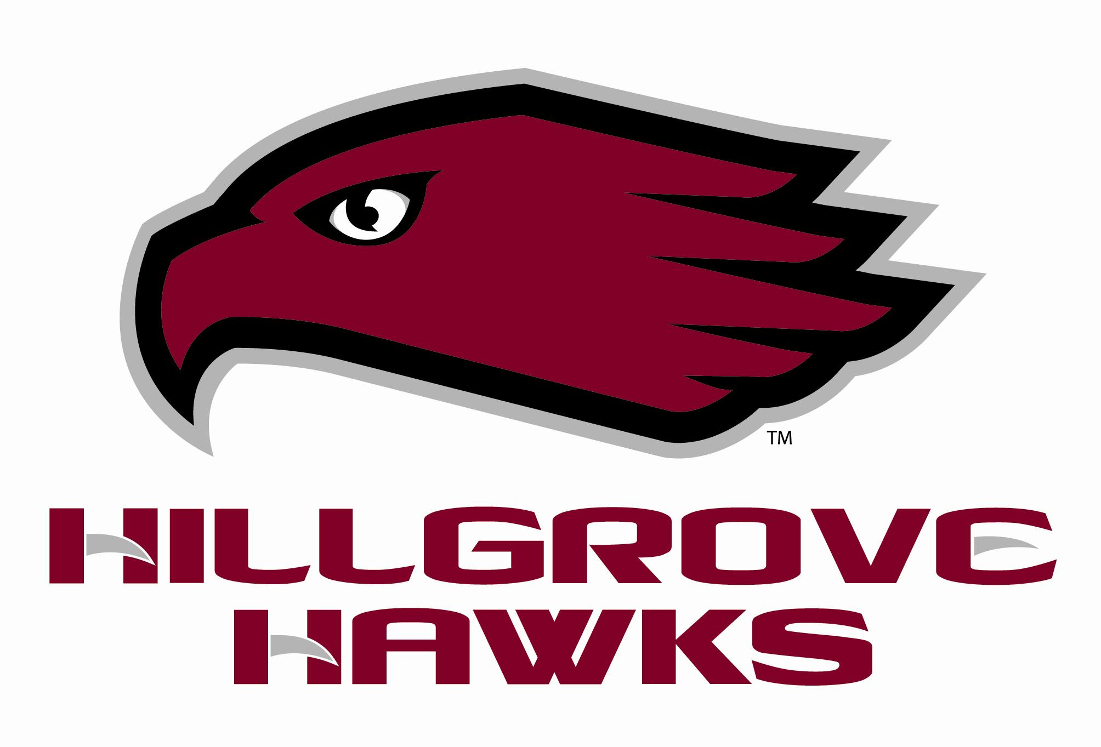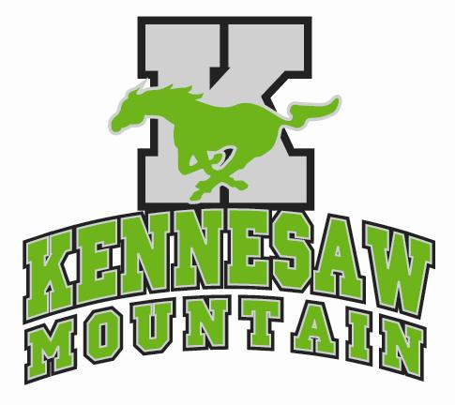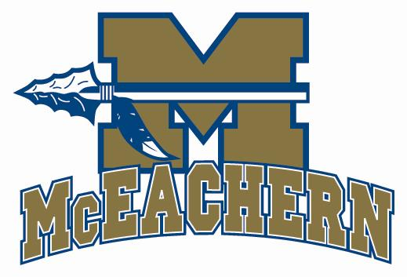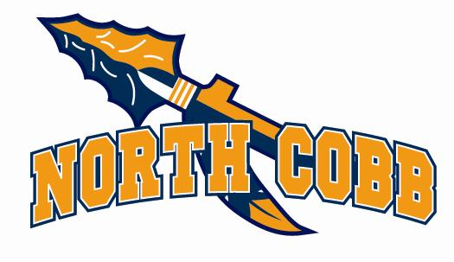

QUEST College Fair

September 2007

Dear Director of Admissions:

Please accept our invitation to participate in QUEST College Fair at Hillgrove High School in Cobb County on Thursday, April 17, 2008 from 6:30 – 8:30 PM. As always, there is no cost involved with participating in this fair.

The QUEST is co-sponsored by Harrison, Hillgrove, Kennesaw Mountain, McEachern, and North Cobb High Schools. The program is specifically intended to target 10th and 11th grade students and their parents to help them explore all post-secondary options including colleges and universities, technical schools, military, etc.

We hope that your institution will participate in this valuable evening. A large number of high schools with diverse student populations in our immediate area are invited to attend.

Please RSVP by telephone at 678-331-1368 ext. 236 or by e-mail to peggy.hurst@cobbk12.org as soon as possible, but definitely no later than March 1, 2008 so that we have adequate time to plan for your attendance.

Please plan to arrive on campus by 5:30 PM so that you will have time to check in and set up materials before students and parents arrive. We also invite you to join us in our hospitality room for a light dinner. Someone will be present to assist you on the Hillgrove High School campus. For additional information, school profiles, and directions to Hillgrove High School, please refer to the QUEST website - http://questfair.tripod.com.

Sincerely,

2008 QUEST Committee

